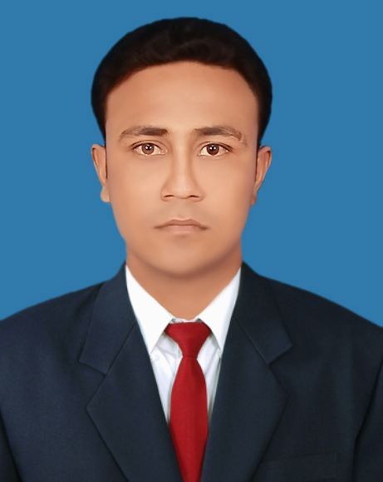
MD. ARIFUL ISLAM
Village- Bamna, Post Office- Ghior,
Police Station- Ghior, District- Manikganj.
Mobile : +8801730903962.

CAREER OBJECTIVE

To build up my career as a Business executive utilizing my knowledge, Hard labor, Innovation ideas and commitment to the organization for its betterment.

SELF-ASSESSMENT

- Analytical, innovative and confident.
- Can make correspondence with various parties.
- Interpersonal skill & ability in a team context.
- Ability to work under pressure.

EDUCATIONAL QUALIFATION

Bachelor of Business Studies (B.B.S Hon’s)
Result : Second Class
Area of Concentration : Major Subject (Management)
Year of Passing : 2009
Name of Institution : Govt. Debendra College, Manikganj.
University : National University.

Higher Secondary Certificate (HSC)
Result : GPA. 3.70
Area of Concentration : Business Studies
Year of Passing : 2005
Name of Institution : Govt. Debendra College, Manikganj.
Board : Dhaka Board.

Secondary School Certificate (SSC)
Result : GPA. 2.81
Area of Concentration : Business Studies
Year of Passing : 2003
Name of Institution : Balia Khora Union High School.
Board : Dhaka Board.

Conted/02

Page-02

LANGUAGE SKILL

- English: Proficient in both Spoken & Written.
- Bengali: Native

COMPUTER LITERACY

Microsoft Office- Word, Excel, PowerPoint, Internet Browsing, E-mail.

PERSONAL DETAILS

Name : Md. Ariful Islam
Father’s Name : Md. Mosharof Hossen
Mother’s Name : Hasna Begum
Milling Address : Village- Bamna, Post Office- Ghior,
Police Station- Ghior, District- Manikganj.
Date of Birth : 15th March 1987.
Marital Status : Single
Religion : Islam
Blood Group : B+
Nationality : Bangladesh by birth.

INTEREST AND ACTIVITIES
Interest reading books, playing cricket, watching movies and listening music.

REFERENCE

Muhammad Amimul Ehsan  Associate Professor  Department of Management  Govt. Debendra College, Manikganj.  Mobile : +8801712292468 | Md. Babul Hossen  Lecturer  Department of Management  Govt. Debendra College, Manikganj.  Mobile :+8801716302714

PROCLAMATION

I do hereby declare that particulars here are true and no false have given.

Thanking you in anticipation

MD. ARIFUL ISLAM

Date:...................

